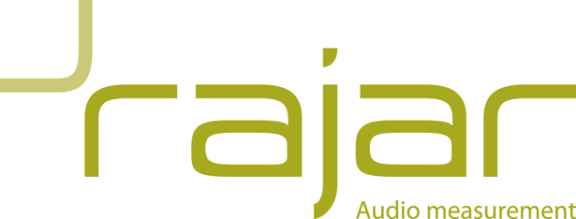

BUREAU SERVICES REGISTRATION FORM 2023

In accordance with the Licence Agreement for Bureau Services between the company named below (the Licensee) and RAJAR, I hereby apply on behalf of the Licensee for registration of the Licensee in relation to the kind or level of data indicated below. The Licensee acknowledges that the subscription year runs from 1st May 2023 – 30th April 2024 and that the licence fee is charged on an annual basis. The Licensee also acknowledges that a separate fee is payable to Ipsos for the production of data, the details of which can be found on the RAJAR website. No discount will be given for bureaux which join after the start of the subscription year or for those who terminate their licence agreement prior to the end of the subscription year. Data will not be released until full payment has been received by RAJAR.

Respondent Level Data: £4,792.00 + VAT  Respondent Level Data (RLD) comes in Ascii format and consists of a series of records for each diary respondent. This allows full flexibility for analysis and is accompanied by weights and area definitions allowing processing before generating usable information. | Yes / No
Aggregate Level Data: £2,353.00 + VAT  Aggregate Level Data comes in csv format. Data is analysed and pre-formatted in tables showing various breakdowns in detail such as listening to individual stations by demographic profiles and quarter hour time segments. | Yes / No
Postcode Level Data  Data comes in Excel format. A definition of each station’s TSA by postcode is listed. The population of each postcode making up the TSA is also provided. This data gives a full breakdown of the TSA geography and offers a population profile by location.  Set-up fee for new Postcode Level Data users: £2,206.00 + VAT  To access Postcode Level Data, you need to either be an existing RAJAR station or non-broadcaster subscriber. If you are not an existing RAJAR subscriber, you will need to pay a set-up fee as well as taking out the relevant Postcode Level Data subscription (below).  Full year (4 quarters): £1,691.00 + VAT | Yes / No  Yes / No

Company Details
Company Name
(Licensee)

Company Address
Companies House
Registration Number
Subscriber Contact Details
Contact Name
Email address

Telephone number

Accounts Department Details
Contact Name of person invoice is to be sent to

Email Address of person invoice is to be sent to

Telephone Number of person invoice is to be sent to

PO number for invoice (if required)

Please sign below to confirm that the details on this form are true and accurate to the best of your knowledge and that you have read and agreed to our Privacy Notice.

Signature

Print Name

For and on behalf of

Date of signing

Licence date (RAJAR use only)

