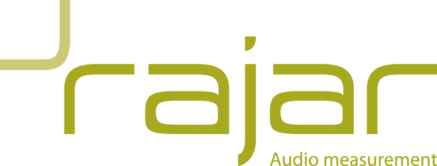

RAJAR NON-BROADCASTER REGISTRATION FORM 2017
The subscription year runs from 1st May 2017 – 30th April 2018 in line with data release.

Radio Audience Book only (electronic copy): £668.00 + VAT

Website: £1929.48 + VAT
Includes:
- Published tables via website
- Website analyses (Quarterly listening analysis, quarter hour report and mapping)
- Radio Audience Book (electronic copy)

Planning System

- Planning System only: £1929.48 + VAT

OR
- Planning System and Website: £2773.44 + VAT

Contact Name

Company

Companies House registration number
Address

Email address

Telephone number

Signature

Date of signing

Payment by cheque or bank transfer
PO number for invoice

